**Multiple Choice: (2 pts ea)**

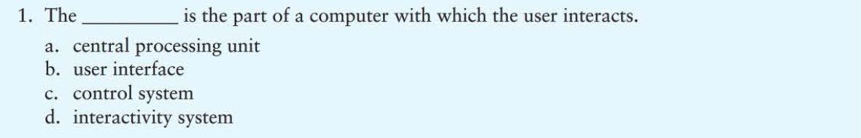

B

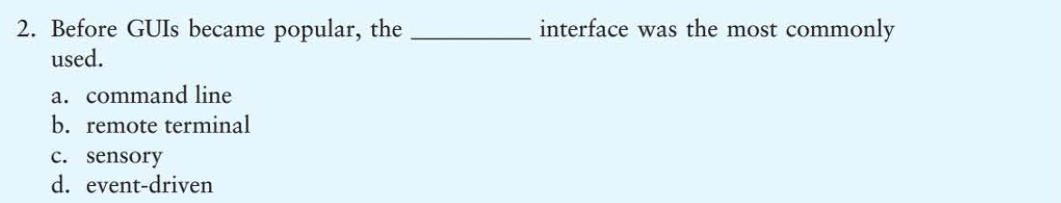

A

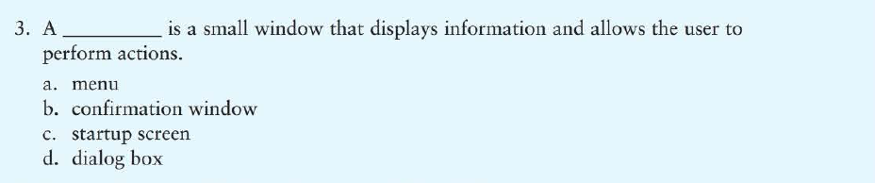

D

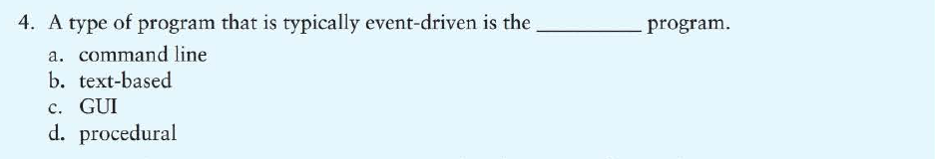

C

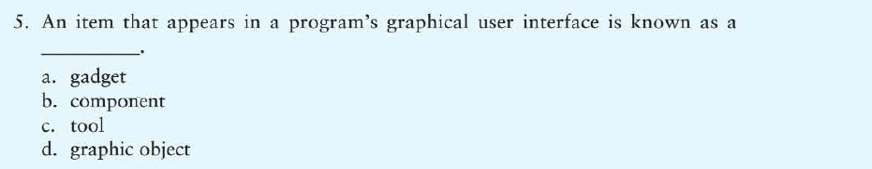

B

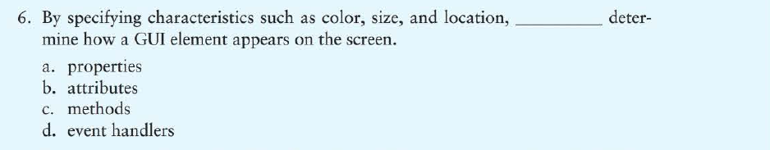

A

**True / False: (1 pt eac)**



**True**

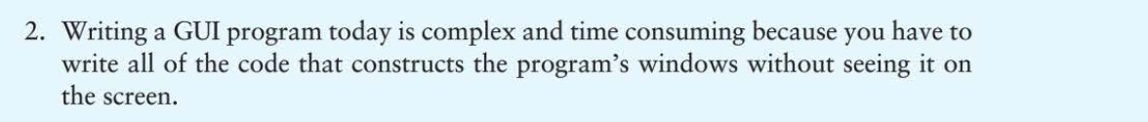

**False**



True



True



True

**Algorithm Workbench: (4 pts each)**

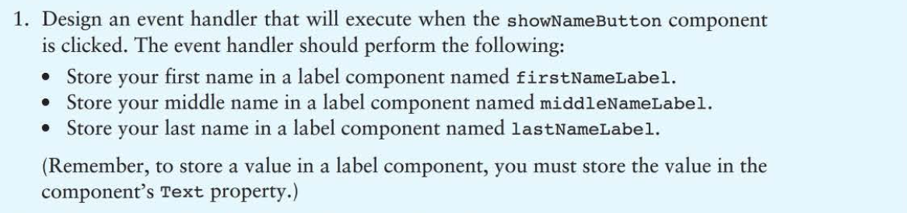

Module showNameButton_Click()

Declare String firstName, middleName, lastName

Set firstName = Cotton

Set middleName = Eyed

Set lastName = Joe

Set firstNameLabel.Text = realToString(firstName)

Set middleNameLabel.Text = realToString(middleName)

Set lastNameLabel.Text = realToString(lastName)

End Module

//

Module exitButton_Click()

Close

End Module

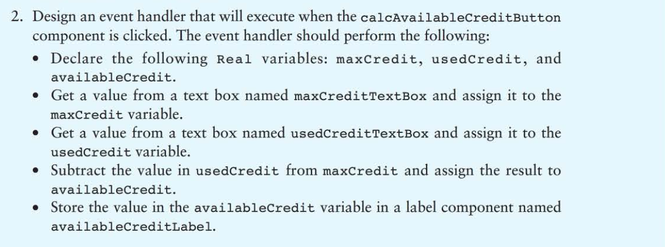

Module calcAvailableCreditButton_Click()

Set Real maxCredit, usedCredit, availableCredit

Set maxCredit = stringToReal(maxCreditTextBox.Text)

Set usedCredit = stringToReal(usedCreditTextBox.Text)

Set availableCredit = maxCredit – usedCredit

Set availableCreditLabel.Text = realToString(availableCredit)

End Module